**COMPUTER HARDWARE**

**MOTHER BOARD**

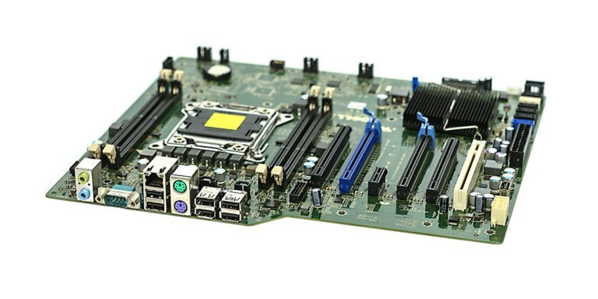

The motherboard is **the backbone that ties the computer's components together at one spot and allows them to talk to each other**. Without it, none of the computer pieces, such as the CPU, GPU, or hard drive, could interact. Total motherboard functionality is necessary for a computer to work well.

The motherboard serves as **a single platform to connect all of the parts of a computer together**. It connects the CPU, memory, hard drives, optical drives, video card, sound card, and other ports and expansion cards directly or via cables. It can be considered as the backbone of a computer.

**RAM MODULES**

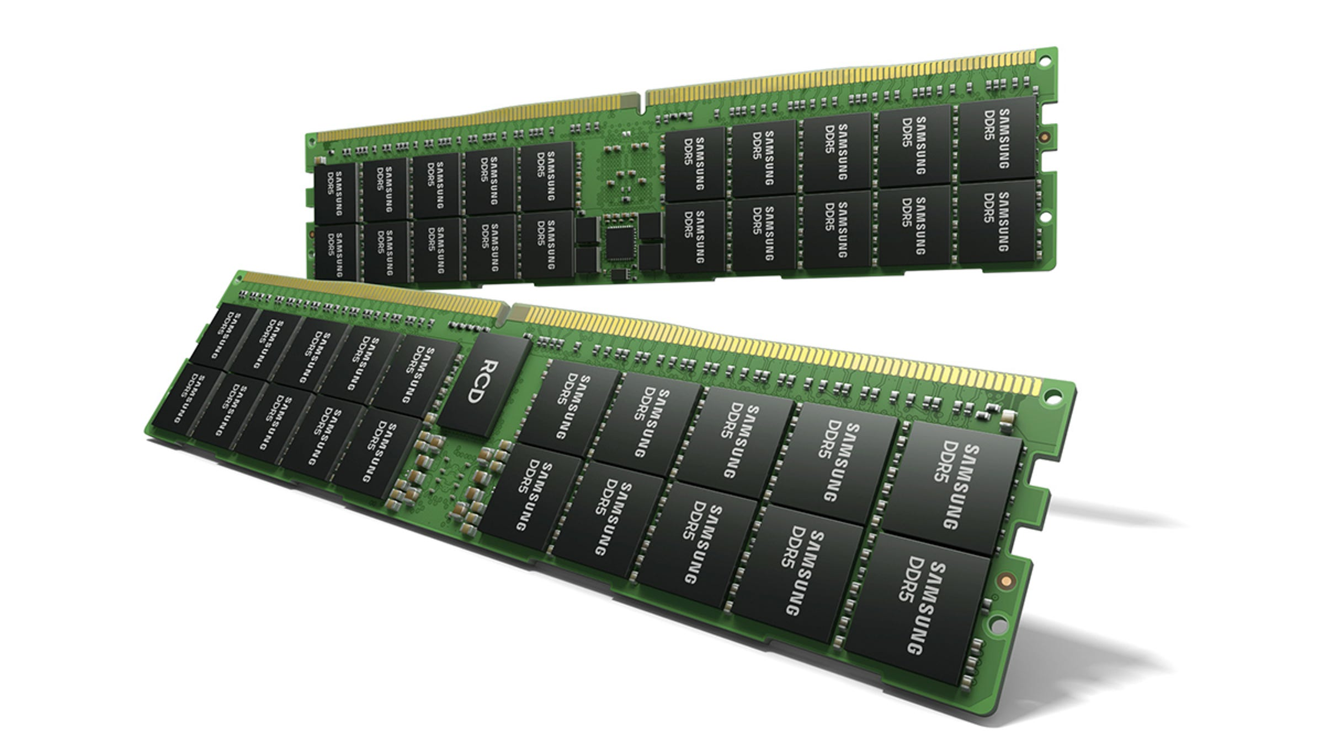

In computing, a memory module or RAM (random-access memory) stick is **a printed circuit board on which memory integrated circuits are mounted**. Memory modules permit easy installation and replacement in electronic systems, especially computers such as personal computers, workstations, and servers.

It can be thought of like a computer's short term memory. It works **by storing common data that programs are in constant use of, rather than storing the data on a much slower medium like a Solid State Hard Drive (or SSD)**. RAM doesn't automatically have data saved on each chip though.

**DAUGHTER CARD**

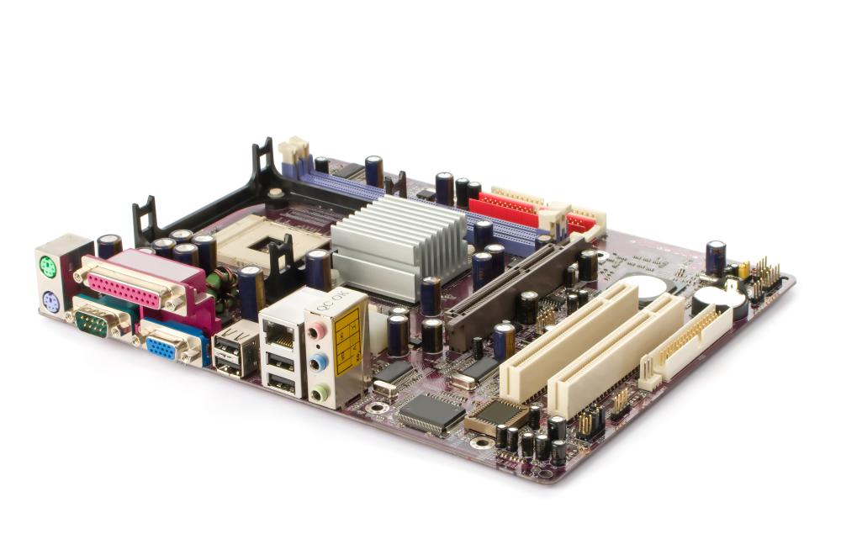

A daughter card or daughterboard is **a type of circuit board that gets added to an existing one**. Its name is appropriate for its use, since it is connected to a “motherboard” or “main board.” The motherboard is the primary circuit board for a device. It is usually in the device as it is shipped from the factory.

Daughter boards are sometimes used in computers in order to **allow for expansion cards to fit parallel to the motherboard, usually to maintain a small form factor**. This form are also called riser cards, or risers.

**BUS SLOTS**

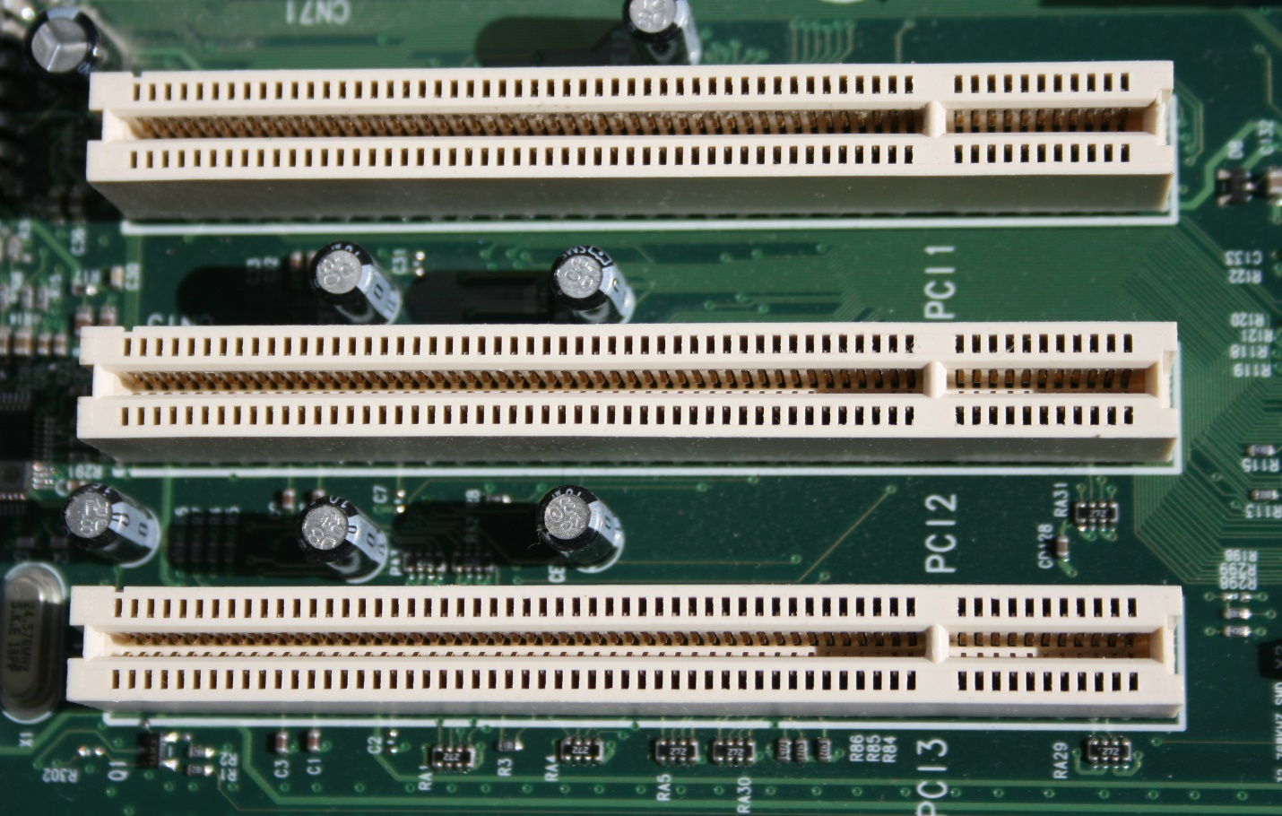

Alternatively known as a bus slot or expansion port, an expansion slot is **a connection or port inside a computer on the motherboard or riser card**. It provides an installation point for a hardware expansion card to be connected.

**There are three different types of expansion slots: PCI Express, PCI, and AGP.**

* PCI – Network card, SCSI, Sound card, Video card.
* PCI Express – Video card.
* AGP – Video card.
* ISA – Network card, Sound card, Video card.
* AMR – Modem, Sound card.
* CNR – Modem, Network card, Sound card.

**SMPS**

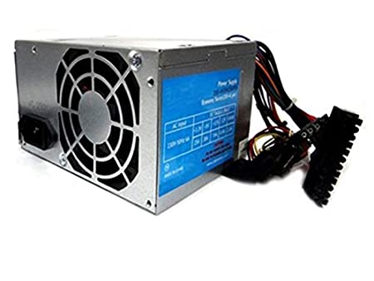

A switched-mode power supply (SMPS) is an electronic circuit that converts power using switching devices that are turned on and off at high frequencies, and storage components such as inductors or capacitors to supply power when the switching device is in its non-conduction state

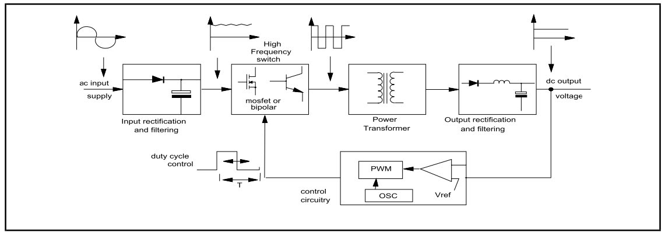

**INTERNAL STORAGE DEVICES**

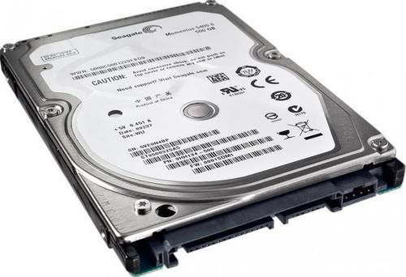

Most computers have some form of internal storage. The most common type of internal storage is the **hard disk**. At the most basic level, internal storage is needed to hold the operating system so that the computer is able to access the input and output devices.

What are internal storage device give example?

Types of Storage Devices

|  |  |  |
| --- | --- | --- |
|  | **Primary Storage Device** | **Secondary Storage Device** |
| Size | Smaller | Larger |
| Data Retention | Temporary | Permanent |
| Location | Internal | Internal / External |
| Examples | RAM, Cache Memory | Hard disk, Compact Disk Drive, USB storage device |

**INTERFACING PORTS**

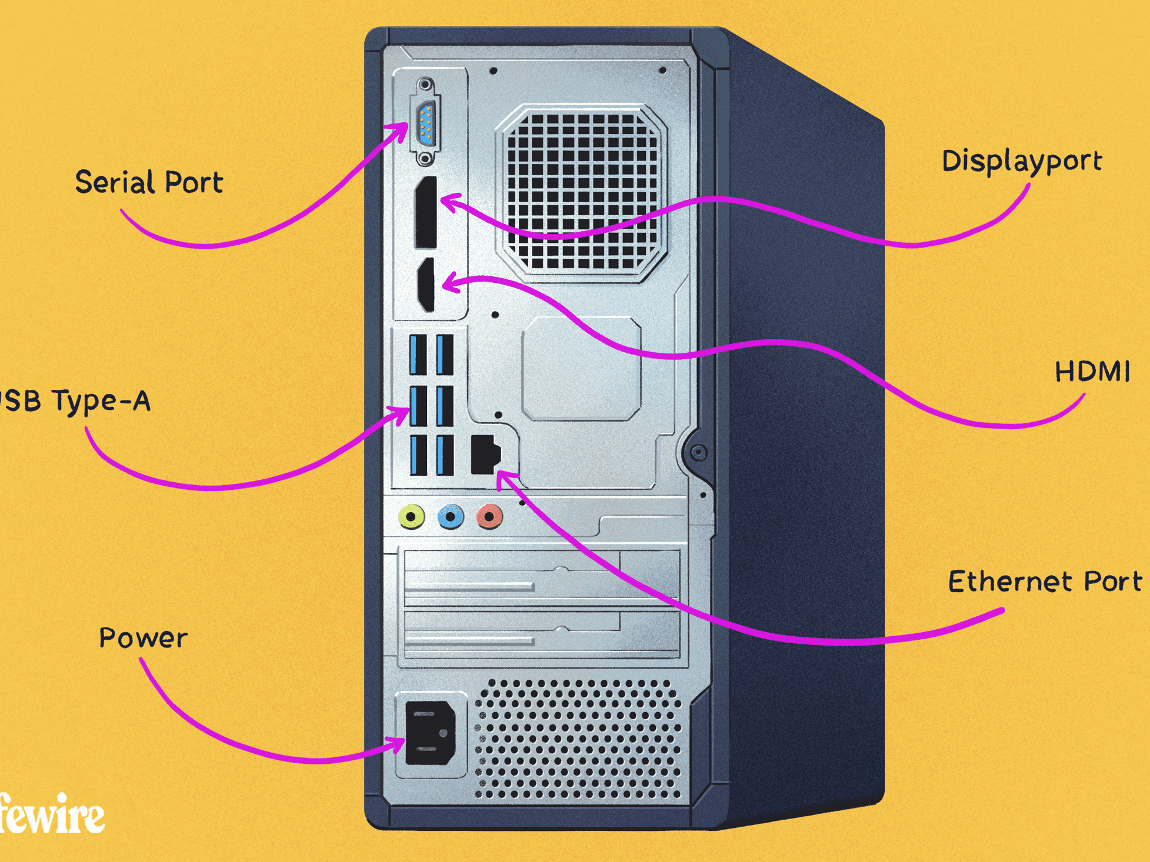

Interfacing ports in computer

This can **connect all kinds of external USB devices**, like external hard disk, printer, scanner, mouse, keyboard, etc. There are minimum of two USB Ports provided in most of the computer systems.  
...  
**Types of Computer Ports**

1. Serial port.
2. Parallel port.
3. USB port.
4. PS/2 port.
5. VGA port.
6. Modem port.
7. FireWire Port.
8. Sockets.

**SPECIFICATIONS OF DESKTOP COMPUTERS**

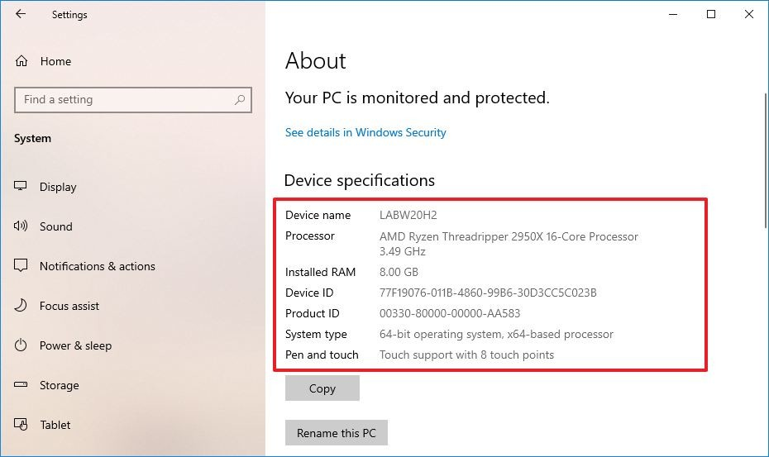

Almost all desktop computers include a **built-in modem and multi-gigabyte magnetic storage drive**. They also feature standard extension slots such as Peripheral Component Interconnect Express (PCIe). They require an uninterruptible power supply (UPS), which means they must be plugged in at all times to function.

**Computer specification (Hardware)**

* Processor speed, model and manufacturer. ...
* Random Access Memory (RAM), This is typically indicated in gigabytes (GB). ...
* Hard disk (sometimes called ROM) space. ...
* Other specifications might include network (ethernet or wi-fi) adapters or audio and video capabilities.

**SPECIFICATIONS OF SERVER CLASS COMPUTERS**

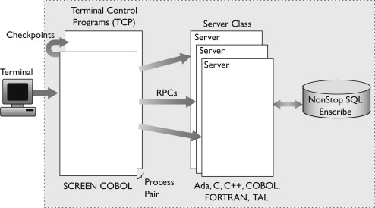

Server specifications **provide detailed information for your server, including dimensions, electrical, power, temperature, environment, and service clearances**.

What is a server class computer?

[[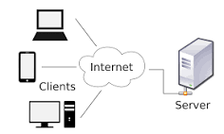](https://www.google.com/search?sa=X&bih=789&biw=1600&rlz=1C1GCEA_enIN838IN838&hl=en&q=What+is+a+server+class+computer?&tbm=isch&source=iu&ictx=1&vet=1&fir=6me34HlYpQyA0M%252CW8DbTCUNo8EHQM%252C_&usg=AI4_-kTWrv7ecBSEor69eJZTuUyxjjdPtw&ved=2ahUKEwiT1Oaiq8f2AhXXwjgGHTzaArsQ9QF6BAgOEAE#imgrc=6me34HlYpQyA0M)](https://www.google.com/search?sa=X&bih=789&biw=1600&rlz=1C1GCEA_enIN838IN838&hl=en&q=What+is+a+server+class+computer?&tbm=isch&source=iu&ictx=1&vet=1&fir=6me34HlYpQyA0M%252CW8DbTCUNo8EHQM%252C_&usg=AI4_-kTWrv7ecBSEor69eJZTuUyxjjdPtw&ved=2ahUKEwiT1Oaiq8f2AhXXwjgGHTzaArsQ9QF6BAgOEAE" \l "imgrc=6me34HlYpQyA0M)

Designating a computer as "server-class hardware" implies **that it is specialized for running servers on it**. This often implies that it is more powerful and reliable than standard personal computers, but alternatively, large computing clusters may be composed of many relatively simple, replaceable server components.